

Interim Assessment of the Thesis
for the Master’s Degree

Name： Peng Zhang
Entrance Date： 2014.9
Thesis Title：Research of magnetic field sensors based on SAW and GMI technology
Discipline：Machinery & Electronics
Supervisor： Hong Hu
Report Date： 2016.3.11

- Does the thesis progress according to the research objectives and schedule as stated in the primary report? (at least 100 words)
The thesis progress mainly according to the schedule as stated in the primary report. The main contents has been completed include simulation of impedance-loaded SAW magnetic field sensors and test of GMI amorphous wire.
There are still some changes. GMI part is the biggest change, which was changed from GMI film to GMI wire because crafts of the GMI film was too expensive to afford. The innovation of this project is that a new method being used into research of SAW magnetic field sensor for the first time.
- The completed work and its related outcomes (at least 1500 words).
1、Simulation of impedance-loaded SAW magnetic field sensors using COM model methods
1.1 Obtain the COM model parameters
To get the mathematical support of design and optimize the IDT structure, I make simulations of impedance-loaded SAW magnetic field sensors by COM model methods.
The COM model is a particular branch of the highly developed theory of wave propagation in periodic media and it has been extensively used in various problems related to optics and electromagnetism since the 1950’s. It was introduced to the SAW field by Suzuki and Haus. The COM model derives from the general field description of wave propagation in periodic media. It deals with acoustic waves propagating in the forward and reverse directions in a distributed structure, such as an IDT or reflection gratings, and incorporates their coupling interaction as they pass through it.
The process of the simulation consist of two steps: firstly using an open source software called FEMSDA to get the stop-band frequency; then coding by MATLAB to get the admittance and S(11) with both in frequency domain and time domain.
In the first step, the open source software FEMSDA was developed by the research group of professor Ken-ya Hashimoto and can be used to analyze the SAW propagation characteristics on infinite metallic grating structures. The software which is combined FEM (finite element method) and SDA (spectral domain analysis) is helpful in getting the COM parameters.
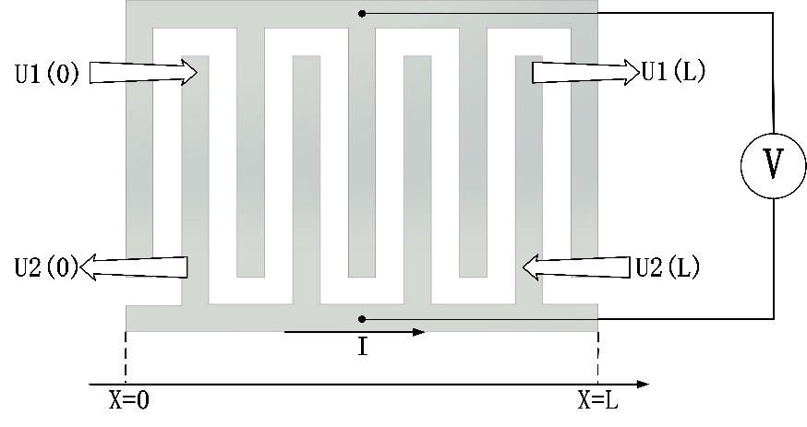
Figure 1-1 COM model schematic
COM model make IDT approximated to the structure shown as figure 1-1, and P matrix is introduced to characterize the energy. P matrix is defined by the following relations under :
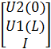=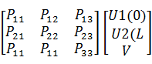 (1-1)
Picture has been obtained of the speed with the relative frequency dispersion curve. The stop-band frequency of SC and OC gate shown in the pictured is =0.4869，=0.4810，=0.4930，=0.4870。
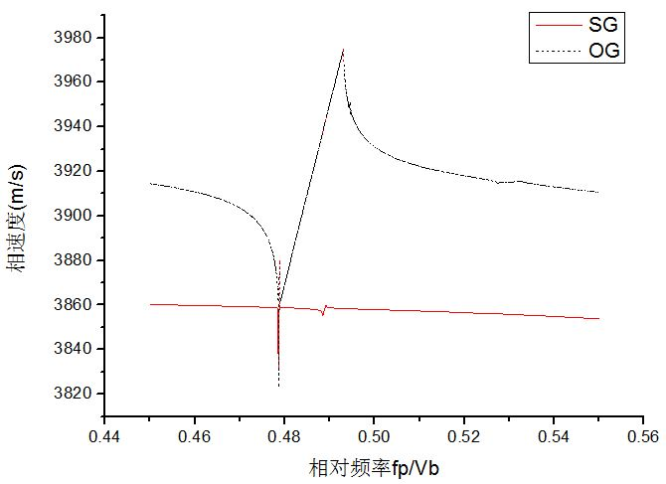
Figure 1-2 Speed with the relative frequency dispersion curve
Then the COM parameters could be calculated by bring the value into some formula.
1.2 Simulation Programming

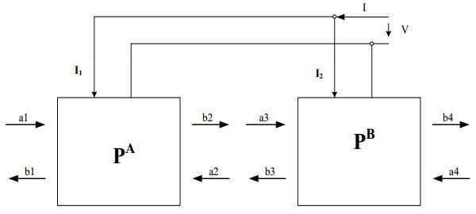
Figure 1-3 P matrix cascade schematic
After the first step, P matrix should be calculated and cascade. The schematic of P matrix cascade is show in figure 1-3.
In the second step, the process is to get the admittance and then transfer it to ABCD matrix and last transfer it to S(11). Then after an IFT program was used to transfer it from frequency domain into time domain.
The results I gained is similar as other research’s results just like LuoWei who was graduated from Huazhong University of Science and Technology, which could prove that I had got the right simulation results.
After this, I could optimize the IDT structure using this COM model and this work is the most important and difficult part of my project. The optimization mainly concentrate in the length between source IDT of reference IDT and loaded IDT, numbers of IDT pairs, height of IDT, and so on.
2、Experiments of GMI (giant magnetoimpedance) wire
To get the most suitable frequency and length of GMI wire, I tested the GMI wire using some instruments. The experiments instruments consist of impedance analyzer、Helmholtz coils and current generator. I have tested four kinds of length of GMI wire which are 5mm、10、15mm、20mm separately and eleven kinds of frequency of current which are 10MHz、20MHz、30MHz、40MHz、50MHz、60MHz、70MHz、80MHz、90MHz、100MHz、110MHz separately.
When a soft ferromagnetic conductor is subjected to a small alternating current (ac), a large change in the ac complex impedance of the conductor can be achieved upon applying a magnetic field. This is known as the GMI effect and the material is the GMI material. In my project I chose GMI wire as the material based on economy and applicability.
2.1 Experimental set-up
GMI amorphous micro-wires material used in this project is the business model 30DC2T no glass-coated amorphous alloy wire with nominal composition ingredients CoFeSiB and a diameter of 30 ± 3μm.
To test the impedance characteristics of the amorphous micro-wires used for this task, we need to set up specific test platform. Impedance test methods for amorphous micro-wires is the four-terminal method, the principle shown in Figure2-1.
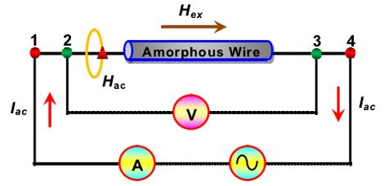
Figure 2-1 Schematic of four-terminal impedance test method
Instruments used for testing are: Agilent 4294A impedance analyzer and related fixtures, Helmholtz coils and current generator. Figure 2-2 is the actual test pattern.
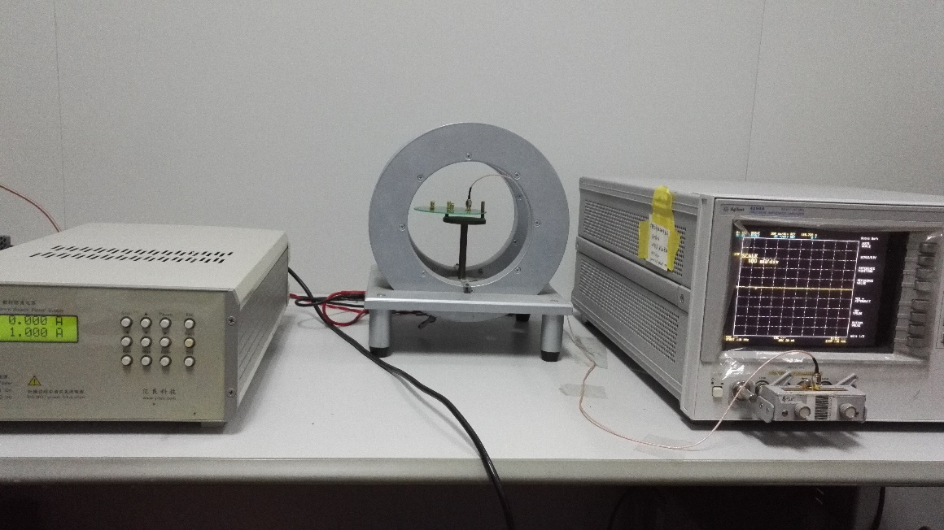
Figure 2-2 actual impedance test chart
2.2 Test different lengths of amorphous micro-wires impedance characteristics
To facilitate the test of different lengths of amorphous micro-wires impedance characteristics, I designed the test PCB board corresponding of the Helmholtz coil. The PCB test board shown in Figure 2-3, which painted with different lengths of white line on the test PCB version and it can be fixed with four SMA connectors. Such a structure to facilitate testing at four different lengths of amorphous micro-wires.
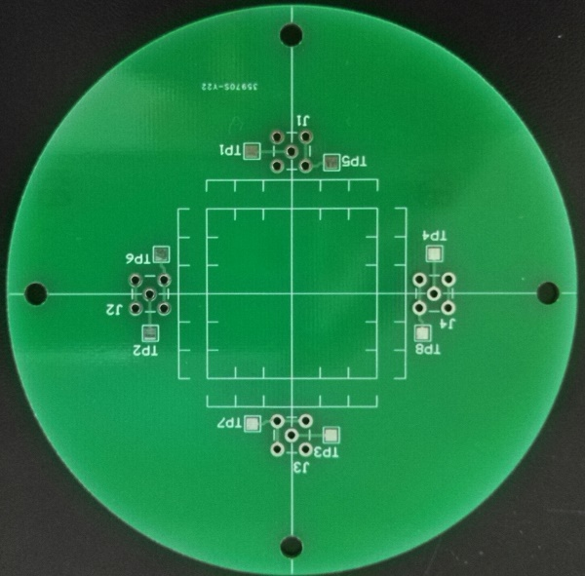
Figure 2-3 PCB figure
Using liquid conductive silver to paste amorphous micro-wires connected with SMA connectors, making respectively length of 5mm, 10mm, 15mm and 20mm amorphous micro-wires fixed on the board.
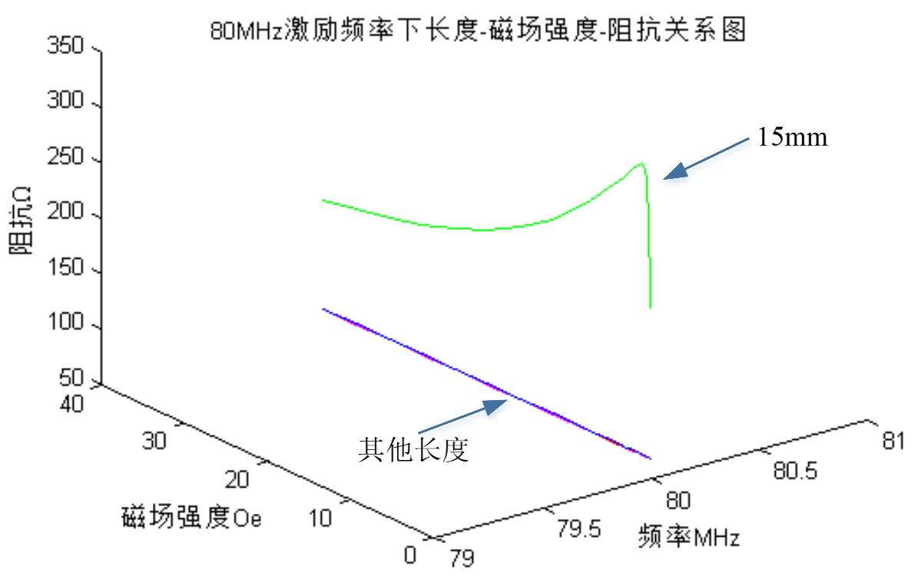
Figure 2-4 80MHz frequency excitation amorphous micro-wires length - field strength - impedance diagram
Figure 2-4 is 80MHz frequency excitation amorphous micro-wires length - field strength - impedance diagram.
2.3 Impedance characteristics of amorphous micro-wires under different excitation frequencies
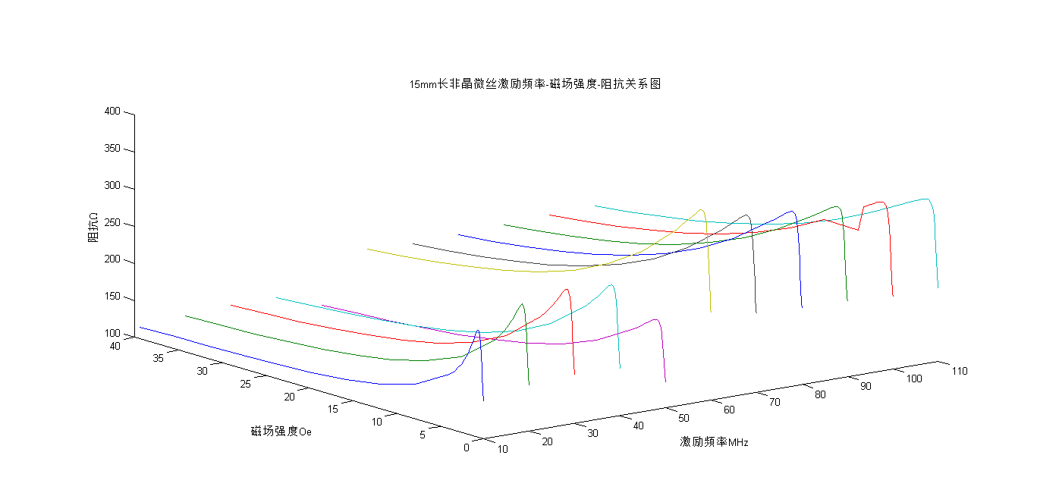
Figure 2-5 15mm amorphous micro-wires excitation frequency -magnetic field strength - impedance diagram
Figure 2-5 is 15mm amorphous micro-wires excitation frequency -magnetic field strength - impedance diagram.
The GMI wire is another particularly important part in my project, which acts as sensitive material with the magnetic field and transfer the change of magnetic field into the change of impedance Z. Then SAW’s amplitude and phase change with the impedance Z.
After the test I analyzed those data by excel and MATLAB to get the dependency of length、frequency and impedance. The data shows that in length with 15mm, the change and accuracy is the best and the most suitable frequency is between 70MHz to 110MHz.
The results I gained is also similar as other research’s results just like Jingshun Liu who was graduated from Harbin Institute of Technology, which could prove that I had got the right simulation results, too.
Considering SAW frequency of papers which I treat as references is 80MHz, so I make the SAW frequency to 80MHz, which will have advantages when I write papers, namely, I could compare the reference papers’ result with my result.
Next work in this part is to connect the GMI wire with IDT after got the chips and test the impedance、capacitance and inductance.
3、Layout and drawing
To make chip factory produce the SAW chips, I made the layout and drew the mask of chips. The chips of impedance-loaded SAW magnetic field sensors consist of two functional module. One is the SAW part and another is the GMI part. Compared with traditional SAW chips there are some special arrangements of the chips in order to connect well with the GMI wire and meet other needs. The software “ledit” was used to draw the mask.
3.1 Design of IDT part
(1) General principles of IDT design
There are so many aspects should be considered in fact, just show the major principles.
- The reflection is much smaller when the IDT move slightly farther from the edge；
- Remain small angle of the substrate could be helpful to reducing the reflection;
- It’s helpful for increasing the busbar of source IDT in connect with SMA connector;
- Electrode reverse between two adjacent IDT.
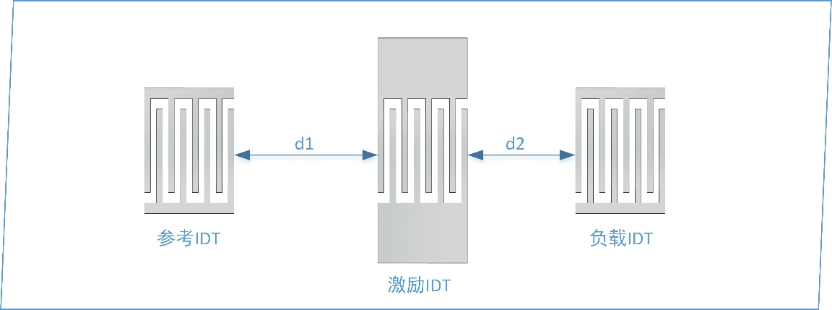
Figure 3-1 SAW chip schematic
Figure 2-19 is the SAW chip schematic according to the above principles
(2) IDT parameters
Table 3-1 IDT parameters
Parameters’ name | Parameters’ value
Center frequency | 80MHz
Periodicity of IDT | 50μm
Finger-width | 12.5μm
Finger-spacing | 12.5μm
Number of IDT | 20
Aperture | 4000μm
Depth of IDT | 1.5μm
Metallization ratio | 0.5
Distance between reference IDT and source IDT | 1000μm
Distance between load IDT and source IDT | 2000μm

3.2 Design of GMI part
GMI material selection amorphous micro-wires length of 15mm, amorphous micro-wires longitudinal direction perpendicular to the longitudinal direction of the IDT，through conductive silver paste amorphous micro-wires and busbars are connected together .
Amorphous micro-wires with the SAW device is connected to consider matching frequency. After the amorphous micro-wires connected with the SAW device , in order to reduce the loss caused due to different center frequencies , so that the maximum sensitivity of the sensor , the need to match the corresponding electronic components , the matching formula is the formula ( 2-26 ) .
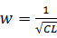 (2-26)
Formula C is the capacitance of the circuit after the match, L is the inductance of the circuit after the match. Because manifested amorphous micro-wires overall inductance is nature, it is necessary to match the corresponding size of its capacitance.
For delay line load impedance structure, the reflected wave contains two parts: mechanical and electro-acoustic reflector portion regeneration section. By setting the thickness of the IDT preceding cycle and the mechanical ratio such that the reflective portion is reduced to negligible , where the load section by the IDT set the same center frequency , circuit loss is reduced , thus maximizing the retention of the electrical energy for the acoustic reproduction section.
Because amorphous micro-wires and rear sensors amorphous micro-wires there will be some differences, so now the measurement data can‘t be used to calculate this, it is necessary after the completion of amorphous micro-wires connected to the sensor chip to test , then the test results into the formula ( 2-26 ) to match calculations.

3.3 Overall chip layout design
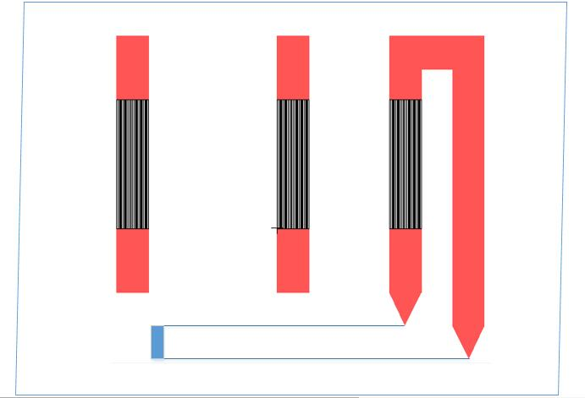
Figure 3-2 Overall chip layout
The following work in this part is to communicate with factory’s engineer to produce the chips and there could still be situation of modify because of the limit of factory’s crafts.

- The work to be completed and its schedule .
Mar.- Apr.2016: Finish the design of chips and give the factory to produce it;
May- Jun.2016: Get the chips and make experiment of the sensors;
Jul.- Aug.2016: Analysis the experiment data to get the result and reason;
Sep.-Oct.2016: Prepared to write papers;
Nov.-Dec.2016: Write thesis and prepare a master's degree thesis defense.
- The existing or expected difficulties and problems.
The sensor chip design may be much more idealistic due to lack of actual production and processing experiences. To solve this problem, I will ask the mentor and senior partner for help and communicate more with staff of the factory.
- The considerations on the possibility of completing the thesis on-time (at least 100 words).
The project focus on new design and analysis of SAW magnetic field sensors based on SAW and GMI technology, which using the scheme with loaded-impedance structure. This scheme and the COM model method being used in the SAW magnetic field sensors for the first time. Main content of this project includes simulation of impedance-loaded SAW magnetic field sensors, test of GMI amorphous wire, matching SAW IDT and GMI wire, experiments of the sensors.
At present, the content of the project has been completed the first two main parts. I believe I can successfully complete the project on time.

